• Understanding human being as a co-existence of the sentient „I‟ and the material
„Body‟
• Understanding the needs of Self („I‟) and „Body‟ - happiness and physical facility
• Understanding the Body as an instrument of „I‟ (I being the doer, seer and enjoyer)
• Understanding the characteristics and activities of „I‟ and harmony in „I‟
• Understanding the harmony of I with the Body: Sanyam and Health; correct appraisal of Physical needs, meaning of Prosperity in detail
• Programs to ensure Sanyam and Health.
Include practice sessions to discuss the role others have played in making material goods available to me. Identifying from one‟s own life. Differentiate between prosperity and accumulation. Discuss program for ensuring health vs dealing with disease
Module-2 | Harmony in the Human Being : (3 hours)
Understanding Human being as the Co-existence of the Self and the Body, Distinguishing between the Needs of the Self and the Body, The Body as an Instrument of the Self, Understanding Harmony in the Self, Harmony of the Self with the Body, Programme to ensure self-regulation and Health

Now we will start exploring the four levels of living of a human being, starting from the level of individual.

Understanding the Human Being
(As Co-existence of Self and Body)
We are human beings; and we need to first understand ourselves.
So, what is a human being? The proposal is that human being is co-existence of the Self and the Body. Self is what we term as „I‟ and Body is what we see with our eyes.

To understand the two realities, we can start by looking at the needs, activities and response of the Self and the Body.
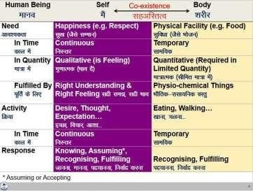

The Needs of the Self and the Body
The need of the Self is happiness (e.g. feeling of respect leading to happiness) while the need of the Body is physical facility (e.g. food). All the needs related to the Self are continuous in time while all the needs related to the Body are required for a limited time. This is one way we can differentiate between the need of the Self and the need of the Body.

The other way to see the difference between the two is in terms of quantity and quality. The need for food is quantitative in nature. We can identify the quantity of the food needed to nurture our body. Same is the case with the need of clothes, shelter, etc. On the other hand, the feeling of respect, trust, etc. is not quantitative. We don’t say, “today I got half kg of respect” or “two metres of trust”. These feelings are qualitative in nature.
Now, let us see how these two different types of needs are fulfilled. The need for food is fulfilled by something physical. But when it comes to the need for respect, it

is fulfilled by the feeling of respect. All the needs related to the Body are fulfilled by some physio-chemical things. All the needs related to the Self are in terms of feeling, and they are fulfilled by right understanding and right feeling.

The Activities of the Self and the Body
The Self has the activity of desire, thought and expectation which are continuous. On the other hand, any activity of the Body, like eating, walking, etc. is temporary in time.

The Response of the Self and the Body
The response of the Body is based on recognizing and fulfilling whereas the response of the Self is based on knowing, assuming, recognizing and fulfilling. The recognition and fulfilment of the Body is definite, while that of Self is determined by the activity of assuming. As assumption changes, the recognition and fulfilment by the Self also changes. The conduct of the human being basically depends upon the response of the Self, as all decisions are made by the Self. Only with the assumptions set right,
i.e. assuming based on knowing (which is definite), can recognising and fulfilling be set right; and only then, the conduct can become definite.

All the problems of a human being are due to assumptions without knowing, and the solution lies in ensuring the activity of knowing. And this is possible only through education-sanskar.
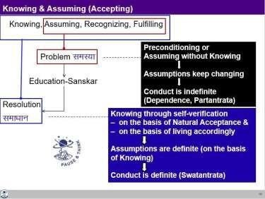

The Self as the Consciousness Entity, the Body as the Material Entity
The Self and the Body are two different types of reality. The Self is the domain of consciousness, which is characterised by the activity of knowing, assuming, recognising and fulfilling. The Body is the domain of material and it only has the activity of recognising and fulfilling.

Happiness is the need of the consciousness and it is fulfilled by right understanding and right feeling, which are activities of the consciousness itself. The Body is a material unit, its needs are material in nature and they are fulfilled by physio- chemical things.

To understand the human being, both the domain of consciousness as well as the domain of material needs to be understood. For human being to be fulfilled, both domains need to be fulfilled separately.

Key Takeaways
Human being is co-existence of the Self (Consciousness) and the Body (Material). This can be seen on the basis of exploring into the need, fulfilment of need, activity and response of the Self and the Body. In particular, the response of the body is definite while the response of the self depends on assuming. With assuming based on knowing, the conduct of a human being gets definite, otherwise it is indefinite.

Gross Misunderstanding – Assuming Human Being to be only the Body
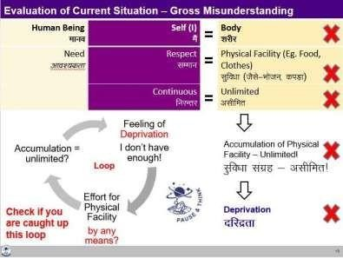
The gross misunderstanding is assuming the human being to be the Body; and therefore, trying to fulfilall the needs through physical facility.

It is needless to say that due to over-use of physical facility, there are widespread repercussions at every level of human existence. On the one hand, there is exploitation of natural resources for more and more physical facility. On the other hand, human beings are exploited in the process and also, they are madeto compete for the limited physical facility.

The Way Ahead
The only way to come out of this misunderstanding is to understand the human being as it is. The Self has to be understood as a conscious entity and Body as a material entity. Their needs are different, activities are different, response is different and basically, they are two different entities co-existing asa human being.

Key Takeaways
The needs of the Self and the Body are of two different types, so they have to be fulfilled separately. A gross misunderstanding is to assume the two to be the same, and this leads to the feeling of deprivation and exploitation.

Understanding Harmony in the Self
Now we will explore into the activities of the Self and see how harmony can be ensured among all the activities of the Self, resulting into a state of continuous happiness.

Activities of the Self
The activities of the Self can be seen in terms of desire, thought and expectation.

Desire is the name given to the activity of imaging. You are making an image in the Self. Desire is in the form of an image which you have created within. Thought is the power for the activity of analyzing based on comparing various possibilities to fulfil your desire. Expectation is the power for the activity of selecting based on tasting.

Activities of the Self are Continuous
These powers of desire, thought and expectation are inexhaustible, and the activities are continuous. The activities of imaging, analyzing-comparing and selecting-tasting are always going on, whether we are aware of them or not.

These Activities Together Constitute Imagination
These activities are together called imagination. We may not immediately be able to observe our desire, thought and expectation distinctly, but it may be easier to see that something is going on within. One imagination or the other is going on in us all the time.

Happiness and unhappiness depend on the state of imagination. If your imagination is in harmony with your natural acceptance, you are in a state of happiness. When it is in contradiction with your natural acceptance, you are in a state of unhappiness.
Imagination is expressed to the world outside, in terms of behaviour with human being and work with the rest of nature.
We have also referred to imagination as “what I am” and the natural acceptance as “what I really want to be”.

State of Imagination
Once you start looking at your imagination, you will be able to find out the state of your imagination. Your imagination could be well organised, in harmony or it could be a random mixture of harmony and contradiction.

Possible Sources of Imagination
There are three possible sources of motivation for imagination: 1. Preconditioning, 2. Sensation and 3.Natural Acceptance

A dominant source of imagination is preconditioning. Preconditioning means the beliefs, notions, norms, ideas, views, dictums, goals, etc. prevailing in the family, in the society which we have assumed without knowing. They may influence our imagination.
Another major source of our desire, our imagination is the sensation. Sensation is the information we get from the Body through the five sense organs – of sound, touch, sight, taste and smell.

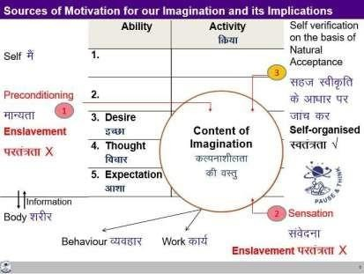

The third source of imagination is our natural acceptance. It can also be referred to as the inner voice or conscience. Self-verification on the basis of our natural acceptance can be the third possible source. It may or may not be the predominant source of motivation currently, but it can be the real source for deciding our desire, our imagination.

Consequences of Imagination from the three Sources
– Self-organisation or Enslavement?

If your imagination is motivated by preconditioning or sensation, you may or may not be in harmony with the natural acceptance. Therefore, you may be in a state of happiness within or unhappiness within. Your happiness is dependent or enslaved by your preconditioning and sensation.

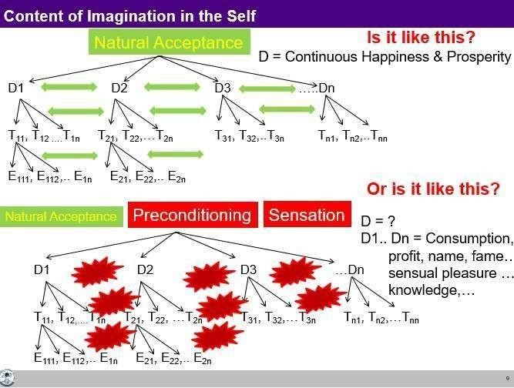

And then there is a large possibility that there is contradiction in your desires, leading to contradiction in your thoughts and then expectations. In such a state of contradiction within, your imagination is enough to keep you unhappy all the time.
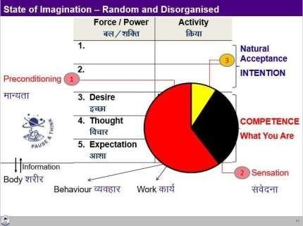

There is a possibility that a large share of your imagination is enslaved by preconditionings and sensations, while a very small share is guided by your natural acceptance. One thing to note here is that sensation is not an enslavement in itself. Through sensation only, the Self is able to take proper care of the Body. But problem arises when you try to associate happiness with favourable sensations. Similarly, there could be some preconditioning which may also be right. But unless you verify it, and validate in your living, it is just like an enslavement. And this leads to unhappiness.

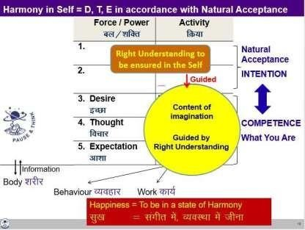

If your imagination is guided by your natural acceptance, you are sure to be in harmony and happiness within. You are self-organized.

The Way Ahead
- Ensuring Harmony in the Self by way of Self-exploration
To achieve this harmony in the Self, we need to start self-exploration. In the process, we need to:
  - Know our natural acceptance
  - Be aware of our imagination
  - Find out the source of imagination
  - Work out a way to sort out our imagination till it is fully in line with our natural acceptance When the imagination is in harmony with the natural acceptance, there is harmony in the Self. This harmony is happiness.

Key Takeaways
The activities of desire, thought and expectation are together called imagination. Imagination is continuously going on in the Self. The sources of imagination can be sensation, pre-conditioning or natural acceptance. There is harmony in the Self when the imagination is in line with one‟s natural acceptance. Harmony in the Self is in continuity when all the activities of the Self are awakened.

Understanding Harmony of the Self with the Body

In this lecture, we will discuss the harmony of the Self with the Body, and try to understand self- regulation and health.

The Body as a Self-organised System
The Body is a wonderful self-organised system. It has so many parts. Each part co- exists in harmony with every other part. The eyes are well connected to the brain; the mouth, the stomach and the whole digestive system is synchronized and so it is for every organ, every cell of the Body – and you have to do nothing to make these connections or to synchronize the various parts or to deal with every cell.

Harmony of the Self with the Body: Self-regulation and Health
As we discussed in lecture 9, the Body is an instrument of the Self. The responsibility of the Self towards the Body is in terms of nurturing, protecting and rightly utilizing the Body. Nurturing the Body is by providing appropriate air, water, food, sunlight, etc. Protection is to ensure the continuity of the body which includes safeguarding from unfavorable conditions. Right utilization would mean using the Body for the purpose of the Self. This feeling of responsibility towards the Body is called as the feeling of self-regulation, and a natural outcome of it is health.

Feeling of self-regulation = the feeling of responsibility in the self towards the Body – for nurturing, protection and right utilization of the Body.
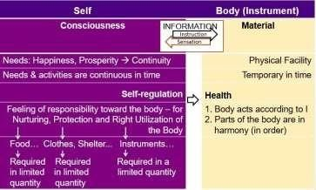

Indicators of a healthy body:
  - The Body is healthy if it is able to perform as per the instructions of the Self.
  - Different parts of the Body are in harmony amongst each other, they are in order.

The feeling of self-regulation in the Self is primary. Health in the Body is a natural consequence.
When the Self has the feeling of self-regulation and there is health in the Body, there is harmony of the Self with the Body.

Appraisal of the Current Status
Over the last 100 years or so, there have been significant improvements in terms of longer life-spans, in dealing with communicable diseases and trauma, but yet, ensuring health remains a question mark¹.The problem is in the wrong assumptions, one of which is that human being is the Body. With this assumption, happiness is sought through favorable sensation through the Body. Further, the assumption that we will get happiness from sensation through the consumption of physical facility has led to a high demand for it. Most of the present-day disorders are psycho-somatic in nature. „Psycho‟ has to do with the Self and „Somatic‟ has to do with the Body. Disharmony in the Self causes disharmony in the Body causing psycho-somatic problems. These effects are very prominent when the individual is living with the assumption “I am the Body”.

The Way Ahead
There is a need to understand human being as it is (as co-existence of Self and Body). The significant part is having the feeling of self-regulation in the Self. This can happen only when the Self is in harmony, i.e. there is right understanding and right feeling in the Self. With a feeling of self-regulation, the Self will naturally nurture, protect and rightly utilize the Body, resulting in health of the Body.

Key Takeaways
The Body is an instrument of the Self. Harmony of the Self with the Body is ensured when Self has the feeling of self-regulation and there is health in the Body.

Programme for Self-regulation and Health
As we discussed earlier, feeling of self-regulation is the feeling of responsibility in the Self for nurturing, protection and right utilization of the Body. We can now detail it further:

Nurturing the Body
Nurturing means providing the necessary inputs to the Body. The right inputs nurture the Body, without disturbing its harmony.

The programme for nurturing and maintaining health of the Body includes the following:1a. Intake 1b. Routine
2a. Physical Labour 2b. Exercise

3a. Balancing internal and 3b. Balancing breathing of body external organs of body
4a. Medicine 4b. Treatment

1a. The first part is the intake, all that the Body takes in. It includes the air it breathes, the water it drinks, the sunlight it absorbs, the food given to it and so on.

1b. A regular routine is required in order to keep the Body healthy, like ensuring a proper programme for sleeping, waking up, cleaning the Body, eating, doing physical work, etc.

2a. The Body needs adequate movement to maintain health. Labour is the work on the rest of nature. Few hours of labour a day provides sufficient body movements to keep the Body in good health. It also ensures production of physical facility.

A lifestyle which includes appropriate intake, routine and labour, would be generally sufficient to keep the Body in good health. However, if we are unable to do that, or in spite of this effort, there is some disharmony in the Body, there are some more aspects of the programme for self-regulation and health, below.

2b. If one is not able to labor, s(he) can do exercises for proper upkeep of the Body.

3a. There is a need for keeping the internal as well as the external organs in harmony by appropriate means like postures, movements etc.

3b. Breathing is a significant activity for the Body. Balancing the breathing of body is necessary, through appropriate breathing exercises.

For the most part, health of the Body can be maintained by these three (1a, 1b, 2a, 2b, 3a and 3b). Despite these, if there is some problem in the health of the Body then we take medicine and ultimately, we also take treatment when all this does not work.
4a. The Body is self-organised and naturally in harmony. It is able to recover itself from many disturbances. But if due to some reasons it runs into disharmony, medicine is helpful in taking care oflifestyle disorders, non-communicable illnesses as well as communicable diseases.

4b. In the event the Body is not in a state to recover itself back to a state of harmony, there is a need fortreatment.

Protecting the Body

Providing a conducive physical environment includes clothing, shelter etc. is all a part of protection of the Body.

Right Utilisation of the Body
Right utilization of the Body would mean that it is used in the process of fulfilling human aspiration, which is basically the need of the Self. If one is using the Body in the process of fulfilling the needs of the Self, it is right utilization of the Body. It would include work with rest of nature to produce physical facility required for the Body.

Revisiting Prosperity in the Light of the Harmony between the Self and the Body
The need for the physical facility is essentially related to fulfillment of this feeling of responsibility towards the Body, i.e. we need physical facility for nurturing the Body (food…), for protecting the Body (clothes, shelter…) and for rightly utilizing the Body (instruments…) and that‟s it. And if we can see this clearly, we can also see that the physical facility required to ensure each one of them is required in limited quantity. Hence, prosperity is very much possible.

As an exercise, one can list all the physical facilities required for these three purposes, and see whether they are limited. Next, one can assess the available facilities, and see if they are more than required. Ifnot, then how much more will be required can be worked out. This will clearly give a vision for ensuring prosperity.

My Participation (Value) regarding Self and my Body
My participation (value) with my Body is:
- Ensuring a feeling of self-regulation in the Self
- Ensuring the nurturing, protection and right utilisation of the Body
- Ensuring the production / availability of more than required physical facility for the above

By ensuring these three, the Body continues to be in harmony, it remains healthy. And one also has the feeling of prosperity.

Key Takeaways
When the Self has a feeling of self-regulation (the responsibility for nurturing, protection and right utilisation of the Body), and it is able to fulfil this responsibility, the Body is in harmony (good health). This feeling of self-regulation is instrumental in identifying the need for physical facility and ensuring prosperity.

